Indian Oil Sales Analysis using Power BI
Project Synopsis

Industrial Training (ECS599)

B.Tech CSE Specialization in AI-ML-DL

SUBMITTED BY:
RAJAT SHARMA(TCA2359164)

November,2025



FACULTY OF ENGINEERING & COMPUTING SCIENCES
TEERTHANKER MAHAVEER UNIVERSITY, MORADABAD
Table of Contents

1 Project Title 3
2 Domain 3
3 Problem Statement 3
4 Project Description 3
4.1 Scope of the Work 3
4.2 Project Modules 3
5 Implementation Methodology 3
6 Technologies to be used 4
6.1 Software Platform 4
6.2 Hardware Platform 4
6.3 Tools 4
7 Advantages of this Project 4
8 Future Scope and further enhancement of the Project 4
9 Team Details 4
10 Conclusion 5
11 References 5

Project Title
Indian Oil Sales Performance Dashboard Using Power BI

Domain
Business Intelligence and Data Analytics
- Sales Analytics
- Oil and Gas Industry Analysis
- Dashboard Development
- Data Visualization

Problem Statement
Indian Oil sells fuel and other products across many places in India. They have a lot of sales data, but it's hard to understand without proper visuals. This project uses Power BI to turn that data into clear charts and dashboards. It helps managers quickly see:
- Which regions are selling more or less
- Which products are performing well
- How sales are changing over time
The goal is to make smart decisions using easy-to-understand visuals.

Project Description
This project focuses on analyzing the sales data of Indian Oil Corporation using Power BI, a powerful data visualization tool. The goal is to create an interactive dashboard that shows sales performance across different regions, products, and time periods. By cleaning and organizing the data, and then visualizing it with charts and graphs, the dashboard helps users:
- Understand which areas and products are performing well
- Spot trends and seasonal changes in fuel sales
- Make better decisions based on clear, visual insights
The project supports smarter business planning by turning raw data into useful information.

Scope of the Work

- Data Collection: Gather sales data from Indian Oil (e.g., region-wise, product-wise, monthly sales).
- Data Cleaning: Remove errors, fill missing values, and format the data for analysis.
- Data Modeling: Organize data into tables and relationships for easy use in Power BI.
- Dashboard Design: Create interactive visuals like bar charts, pie charts, and maps.
- Sales Analysis:
  - Compare sales across regions and products
  - Identify top-performing areas and products
  - Track monthly or yearly trends
- User Interaction: Add filters and slicers so users can explore the data easily.
- Report Sharing: Publish the dashboard for use by managers or decision-makers.

Project Modules
- Data Collection
Collect sales data from Indian Oil, including region, product type, and time period.
- Data Cleaning
Remove errors, fill missing values, and prepare the data for analysis.
- Data Modeling
Organize the data into tables and set relationships in Power BI.
- Dashboard Design
Create charts, graphs, and maps to show sales performance.
- Sales Analysis
Compare sales by region and product, find top-selling items, and observe trends.
- User Interaction
Add filters and slicers so users can explore the data easily.
- Report Publishing
Share the final dashboard with decision-makers for better planning.
5 Implementation Methodology
Step 1: Data Collection
Sales data is collected from Indian Oil’s internal sources (e.g., Excel, CSV files) including region, product, and time-based sales.
Step 2: Data Cleaning & Preparation
Using Power Query in Power BI:
- Remove duplicates and null values
- Format columns (e.g., date, numbers)
- Create calculated columns if needed
Step 3: Data Modeling
- Define relationships between tables (e.g., Region ↔ Sales, Product ↔ Sales)
- Use star schema for efficient querying
- Create measures using DAX (e.g., Total Sales, Average Sales)
Step 4: Dashboard Design
- Build interactive visuals: bar charts, pie charts, line graphs, maps
- Add slicers for filtering by region, product, and time
- Use bookmarks and tooltips for better user experience
Step 5: Testing
- Functional Testing: Check if filters, visuals, and calculations work correctly
- Data Validation: Cross-check totals with raw data
- User Testing: Get feedback from sample users for usability
Step 6: Defect Log Maintenance
- Maintain a simple Excel sheet to log issues
  - Columns: Issue ID, Description, Module, Status, Date Raised, Date Resolved
- Update the log during testing and fix issues before final deployment
Step 7: Report Publishing
- Publish the dashboard to Power BI Service
- Set up scheduled data refresh
- Share with stakeholders via secure links
- ER Diagram (Entity-Relationship)
Entities: Region, Product, Sales
Relationships:
- One region has many sales
- One product appears in many sales
Step 8: Requirement Analysis
- Understand the business goals of Indian Oil: tracking fuel sales, regional performance, and customer trends.
- Identify key stakeholders and their data needs (e.g., sales managers, executives).
- Define KPIs such as total sales, average transaction value, product-wise performance, and regional comparisons.
Step 9: Validation
- Perform unit testing on DAX formulas and visual filters.
- Validate data accuracy by cross-checking with source files or sample calculations.
- Conduct user acceptance testing (UAT) with stakeholders to ensure usability and relevance.
Step 10: Deployment and Sharing
- Publish the dashboard to Power BI Service for cloud access.
- Set up scheduled data refresh to keep insights up to date.
- Share reports with stakeholders via email, Teams, or embedded links.

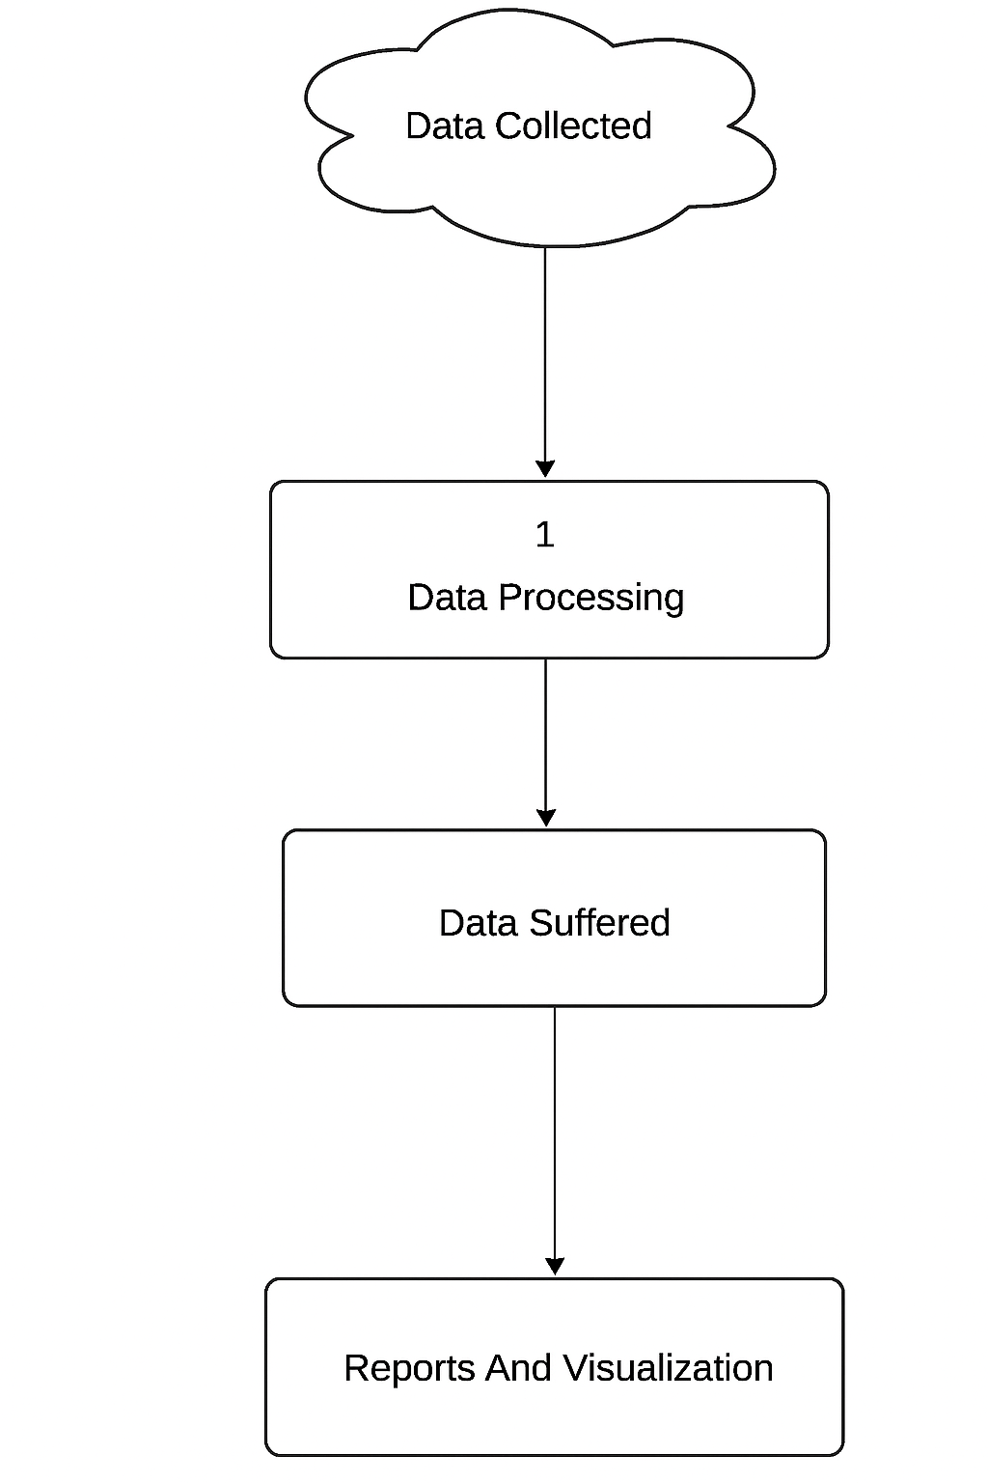

6 Technologies to be used
- Power BI
For creating dashboards, charts, and interactive reports.
- Microsoft Excel / CSV Files
Used as the source for collecting and storing sales data.
- Power Query
For cleaning and transforming data inside Power BI.
- DAX (Data Analysis Expressions)
To create calculated columns and measures (e.g., Total Sales, Average Sales).
- Power BI Service
For publishing and sharing the dashboard online.

Software Platform
This project uses a combination of front-end and back-end technologies to collect, process, analyze, and visualize Indian Oil’s sales data. The platform is designed to be user-friendly, efficient, and capable of handling large datasets with ease.
- Front-end
The front-end is the part of the system that users interact with directly. In this project, the front-end is built using Power BI, which provides a rich and interactive interface for data visualization.
- Power BI Desktop: Used to design and develop dashboards, charts, and reports. It allows users to create visuals like bar graphs, pie charts, line charts, and maps to represent sales data clearly.
- Power BI Service: After development, the dashboard is published to Power BI Service, where it can be accessed online by stakeholders. It supports sharing, collaboration, and scheduled data refresh.
- User Interaction Features: Slicers, filters, drill-throughs, and tooltips are added to make the dashboard interactive. Users can explore data by selecting regions, products, or time periods.
This front-end enables decision-makers to gain insights from the data without needing technical knowledge.
• The front-end (Power BI Dashboard) provides a visual and interactive experience for users.

- Back-end
The back-end handles data storage, processing, and logic. It ensures that the data used in the front-end is clean, structured, and ready for analysis.
- Data Sources: Sales data is collected from Excel files or CSV formats, which include fields like region, product type, quantity sold, and sales amount.
- Power Query: This tool within Power BI is used for data cleaning and transformation. It removes duplicates, fills missing values, formats columns, and prepares the data for analysis.
- Data Modeling: Tables are linked using relationships (e.g., Region ↔ Sales, Product ↔ Sales). A star schema is used to optimize performance and simplify queries.
- DAX (Data Analysis Expressions): DAX is used to create calculated columns and measures such as Total Sales, Average Sales, and Year-over-Year Growth. These calculations power the visuals in the dashboard.
• The back-end (Excel/CSV, Power Query, DAX) handles data preparation, modeling, and logic.

Hardware Platform
To successfully develop and run the Power BI-based sales analysis project, the following hardware and software components are recommended:
Minimum Hardware Requirements
COMPONENT | SPECIFICATION
RAM | 8 GB or higher
HARD DISK | 500 GB (minimum 2 GB free for Power BI)
PROCESSOR | Intel i5 or equivalent (64-bit)
DISPLAY | 1366 x 768 resolution or higher

Tool

1. Power BI Desktop
- Vendor: Microsoft
- Version: Power BI Desktop (October 2025 release or latest)
- Purpose:
  - Used for designing dashboards and reports
  - Supports data modeling, DAX calculations, and interactive visuals
  - Central tool for front-end development and visualization
2. Microsoft Excel
- Vendor: Microsoft
- Version: Microsoft Excel 2016 or later
- Purpose:
  - Used for collecting and storing raw sales data
  - Acts as a primary data source for Power BI
  - Supports basic data cleaning and formatting
3. Power Query (Built-in with Power BI)
- Vendor: Microsoft
- Version: Integrated with Power BI Desktop
- Purpose:
  - Used for data transformation and cleaning
  - Helps remove nulls, format columns, and merge datasets
4. DAX (Data Analysis Expressions)
- Vendor: Microsoft
- Version: Built-in with Power BI Desktop
- Purpose:
  - Used to create calculated columns and measures
  - Enables dynamic calculations like Total Sales, Average Sales, etc.
5. Power BI Service
- Vendor: Microsoft
- Version: Cloud-based platform (2025 version)
- Purpose:
  - Used to publish and share dashboards online
  - Supports scheduled data refresh and user access control

7 Advantages of this Project

- Improved Decision-Making
Managers can quickly understand sales trends and make smarter business choices.
- Time-Saving Visuals
Interactive dashboards replace manual reports, saving time and effort.
- Real-Time Insights
With scheduled data refresh, users get up-to-date sales performance anytime.
- Easy Data Exploration
Filters and slicers allow users to explore sales by region, product, or time.
- Error Reduction
Automated calculations and visuals reduce human errors in analysis.
- Scalable and Shareable
Dashboards can be shared online and scaled for different departments or regions.
- Better Resource Allocation
Helps identify low-performing areas and products, guiding marketing and supply decisions.

8 Future Scope and further enhancement of the Project
his project lays the foundation for data-driven decision-making at Indian Oil. In the future, several enhancements can be made to improve its impact and usability:
1. Live Data Integration
Connect Power BI directly to Indian Oil’s internal databases or cloud systems to enable real-time sales tracking and automatic updates.
2. Predictive Analytics
Use machine learning models to forecast future sales trends, seasonal demand, and product performance.
3. Mobile Dashboard Access
Optimize dashboards for mobile devices so managers can view insights on the go.
4. Customer Behavior Analysis
Integrate customer feedback and purchase patterns to understand preferences and improve marketing strategies.
5. Geo-Mapping Enhancements
Add advanced map visuals to track sales performance by city, district, or fuel station.
6. Alert System
Set up alerts for sudden drops or spikes in in sales, helping managers respond quickly.
7. Multi-Department Integration
Extend the dashboard to include inventory, logistics, and finance data for a complete business overview.
8. Sustainability and ESG Reporting
Future dashboards can include metrics related to carbon emissions, renewable energy usage, and sustainability goals. This will help Indian Oil align with global ESG standards and communicate its environmental impact transparently.
9.Cross-Functional Integration
The dashboard can be expanded to include data from other departments such as logistics, finance, and customer service. This holistic view will help Indian Oil make strategic decisions that align with overall business goals, not just sales performance.

10.Customer Behavior and Loyalty Analysis
By integrating CRM data, Indian Oil can analyze customer preferences, fuel usage patterns, and loyalty program effectiveness. This will support personalized marketing and improve customer retention.
11.Mobile and Cloud Accessibility
Deploying dashboards on Power BI Mobile and Power BI Service (cloud) ensures that executives, field officers, and station managers can access insights anytime, anywhere. This mobility enhances operational agility and supports decentralized decision-making.

9 Team Details

Project Name & ID | Course Name | Student ID | Student Name | Role | Signature
 |  | TCA2359144 | PALCHHIN JAIN
 |  | TCA2359164 | RAJAT SHARMA

10 Conclusion
The Indian Oil Sales Analysis project successfully demonstrates how modern data visualization tools like Power BI can transform raw sales data into meaningful business insights. The innovative use of interactive dashboards, dynamic filters, and real-time data refresh sets this project apart from traditional reporting methods.
Key achievements include:
- Clean and structured data modeling using Power Query and DAX
- Region-wise and product-wise sales comparison through intuitive visuals
- User-friendly interface for quick decision-making and performance tracking
What makes this system stand out is its scalability, ease of use, and potential for future enhancements like predictive analytics and mobile access. By integrating technology with business intelligence, this project supports smarter planning and efficient resource allocation for Indian Oil.

11 References
- Books & Study Material
  - “Power BI Cookbook” by Brett Powell
  - “Microsoft Power BI Quick Start Guide” by Devin Knight
  - “Data Analytics Made Accessible” by Anil Maheshwari
- Websites & Online Resources
  - https://learn.microsoft.com/en-us/power-bi/ – Official Power BI documentation
  - https://docs.microsoft.com/en-us/dax/ – DAX formula reference
  - https://www.sqlbi.com/ – Tutorials and articles on Power BI and DAX
  - https://www.kaggle.com/ – Sample datasets and data analysis projects
- Tools Used
- Power BI Desktop – Microsoft Corporation
- Microsoft Excel – Microsoft Corporation
- Power BI Service – Microsoft Cloud Platform

